American Society of Mechanical Engineers
Hong Kong Section – International Symposium on Advanced Boiler Technology & Workshop
21 - 23 June 2017, Hong Kong
Symposium Venue: Chiang Chen Studio Theatre, The Hong Kong Polytechnic University
Workshop Venue: N102, The Hong Kong Polytechnic University

The science and technology of boiler technology has been a cornerstone of energy generation for the last 150 years, and it is still relevant in a foreseeable future. With the recent strive in emission control and reduction in carbon production, the need to achieve better performance while minimizing losses has grown ever more important. This is a hard-pressing matter for the Asia Pacific region, where most countries in the region saw immense economic growth over the past 30 years. Emergent economies also mean growing energy demands, while energy operators are working hard to balance between tightening emission standards and controlling operating costs.

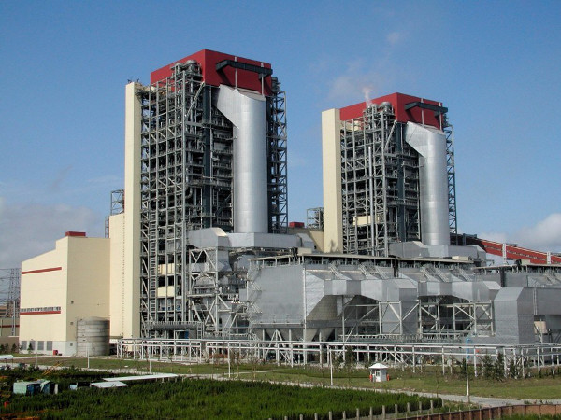
Therefore, there is a great need for energy operators around the world to master the latest development in advanced boiler technologies - what are the plausible engineering solutions to improve their existing boilers to conform to new emission standards. For operators looking for new assets, they want to know all plausible engineering solutions, and all the tangible benefits of such solutions.

The American Society of Mechanical Engineers (ASME) Hong Kong Section is proud to present the International Symposium on Advanced Boiler Technology and Workshop. ASME has been the leader in setting standards for boiler design and operation which are revolving around power industry, thanks to its robust system. The three-day event comprises of two major activities:
- Advanced Boiler Technology Workshop (Day 1 & 2)
- International Symposium on Advanced Boiler Technology (Day 3)

We aim at attracting engineers and professionals from boiler and energy disciplines to join this event in Hong Kong and our ultimately goal is to provide a platform for advance boiler technology knowledge sharing as well as the experience sharing on best practices on asset management and operation control. In this innovative series of activates, different focuses on state-of-the-art boiler technologies and related topics will be included such as:
- Hyper-Supercritical (HSC) Boiler Plant design
- Damage tolerant design
- Experience sharing in Asset Management
- Design Analysis of real-world examples
- Future design challenges
- Worked examples of boiler designs

Advanced Boiler Technology Workshop (21-22 June 2017)

Day 1 (21 June 2017)
Time | Activities |  | Delivered by
09:00 – 09:30 | Registration
SESSION I – Boiler Design Overview
0930 – 10:45 | - History of Boiler Development  - Current Designs |  | Mark Upton  (Chief Process Engineer, Doosan Babcock)
10:45 – 11:00 | Tea Break
11:00 – 12:00 | 3. The Future |  | David Anderson  (Chief Engineer, Doosan Babcock)
12:00-13:30 |  | Lunch Break
SESSION II – Internationally Recognized Design Code Comparisons
13:30 – 15:00 |  | - ASME/EN  - GB/ASME | Stuart Cameron  (Governor, ASME)  Dr Dong Mei Finch  (Specialist Consultant,  Harbin Boiler Company)
15:00 – 15:15 |  | Tea Break
SESSION III – Revisions to ASME Section I
15:15 – 16:45 |  | - Overview of the TG-Modernization work  - Advantages of applying Design by Analysis Methods for High Temperature Components Operating in Advanced Power Generating Plant | David Anderson  (Chief Engineer, Doosan Babcock)  Jonathan Parker  (EPRI)
16:45 |  | Day 1 Ended

Advanced Boiler Technology Workshop (21-22 June 2017)

Day 2 (22 June 2017)
Time | Activities | Delivered by
09:00 – 09:30 | Registration
SESSION IV – Worked Examples for Boiler Components
09:30 – 10:45 | - ASME Section I DBR Examples  - DBA Examples | David Anderson & others  (Chief Engineer, Doosan Babcock)
10:45 - 11:00 | Tea Break
11:00 - 12:15 | - DBA Examples  - Comparisons of DBR and DBA Calculations | David Anderson  (ASME Modernization Task Group)
12:15-13:30 | Lunch Break
SESSION V –Inspection and Maintenance Best Practice
13:30 – 15:00 | Session 5.1: Best international practices in power boiler inspection and maintenance | Simon Cadwallader  (Head of integrity, Doosan Babcock)
15:00 – 15:15 | Tea Break
15:15 – 15:45 | Session 5.2 Part 1: Best local practices in power boiler inspection and maintenance – CLP Prospective | Lau Chak Lam (Senior Engineer, CLP)
15:45 – 16:15 | Session 5.2 Part 2: Best local practices in power boiler inspection and maintenance – HK E Prospective | S.L. Lam (Engineer, HKE)
16:15 – 17:00 | Open Forum | All speakers

Rundown for ISABTW Symposium (23 Jun 2017)
Time | Activities | Title | Speaker
08:15 – 08:45 | Registration
08:45 – 08:50 | Opening Remark |  | Ron Chung  (Section Chair, ASME HK)
08:50 – 09:00 | Welcome Address |  | Ir Tai  (Deputy Director, EMSD)
09:00 – 09:30 | Keynote Speech | Priorities for Advancing Boiler Technology (Keynote) | Tom Loughlin  (Executive Director, ASME)
09:30 – 09:40 | Keynote speech - Q & A (Session Chair: Prof Stuart Cameron)
09:40 – 09:50 | Souvenir Presentation & Group Photos
09:50-10:00 | Tea Break
Session I (10:00-12:00)
10:00 – 10:30 | Technical Paper 1 | A Comparison of the ASME and European Standards to achieve safe boiler operation | Stuart Cameron  (Governor, ASME)
10:30 - 11:00 | Technical Paper 2 | Design by Analysis Methods in the Modernized Code | David Anderson  (Chief Engineer, Doosan Babcock)
11:00 -11:30 | Technical Paper 3 | Damage Tolerance Considerations for High Energy Components Manufactured from Creep Strength Enhanced Steels | Jonathan Parker  (Technical Executive, EPRI)
11:30 - 12:00 | Technical Paper 4 | Steam Power: Boilers and Hong Kong’s Community Life Now and Beyond | SAM Kai-pong, Derek  (Senior engineer, EMSD)
12:00 - 12:20 | Session I - Q&A (Session Chair: Ir. CW Tso)
12:20 – 13:20 | Lunch Break
Session II (13:20-15:40)
13:20 - 13:50 | Technical Paper 5 | Water-Tube Boiler Pressure Part Design – Comparisons between ASME and Chinese Design Codes | Dr Dong Mei Finch  (Specialist Consultant,  Harbin Boiler Company)
13:50 – 14:20 | Technical Paper 6 | Advanced Boiler Design | Yoshiyuki Wakabayashi  (Executive Vice President, MHPS)
14:20 - 14:50 | Technical Paper 7 | Aspects of boiler tube material selection from a designer’s perspective | Mark Upton  (Chief Process Engineer, Doosan Babcock)
14:50 – 15:20 | Technical Paper 8 | Application of advanced ultra-supercritical technology in Fangchenggang phase II units | Liang Fahua, HUANG Yilong  (Dongfang Boiler, China)
15:20 -15:40 | Session II - Q&A (Session Chair: Ir. Chris Cheung)
15:40 – 15:50 | Tea Break
Session III (15:50 – 17:40)
15:50 - 16:20 | Technical Paper 9 | GE’s Advanced Boiler Technologies - State-of-the-Art & New Developments | Dr. Qiurong CHEN  (Senior Technical Expert - Boiler, GE Power Wuhan)
16:20 - 16:50 | Technical Paper 10 | Heat Transfer Restoration in HRSG | YU Chung Man, Victor  ( CLP Power HK)
16:50 - 17:20 | Technical Paper 11 | Safety in Design and Installation of HRSG | KWONG Kwing Lam, Johnny  ( HK Electric)
17:20 - 17:35 | Session III Q&A (Session Chair: Ir. Nelson Yu)
17:35 - 17:40 | Closing Remark |  | Thomas Cheong  (Section Vice Chair, ASME HK)

